Experiment 10: light sound experiment
This experiment, although very simple, but very useful and interesting. This circuit is commonly used, hope the reader to remember this usage, draw inferences about other cases from one instance. This is the purpose. According to the intensity of the light, buzzer sound frequency, intensity is high, the sound is more rapid.

.1、Experimental device
 Photosensitive resistance: 1
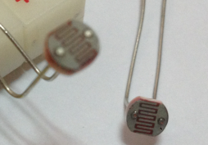
 Buzzer: 1
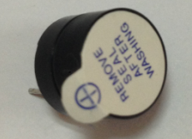
 Colorful bread board Jumper: some experiments
2、Experimental connection
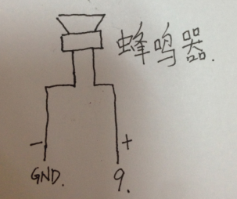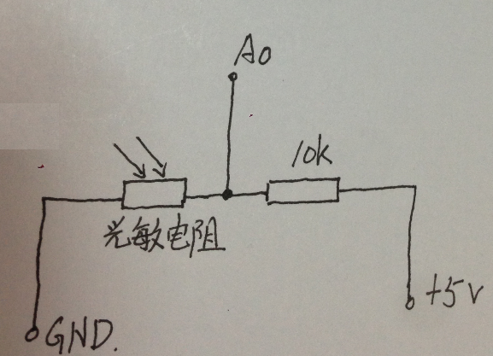
Circuit connection diagram：
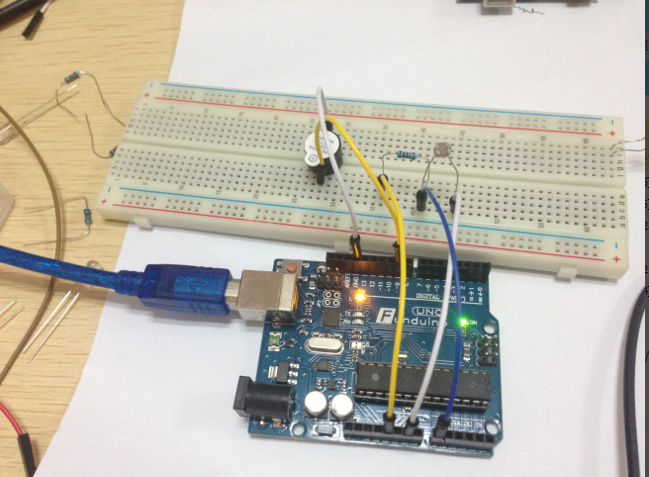

3、Experimental principle
This procedure applied in front of several sections read analog port voltage value of the method, the photosensitive resistor directly connected to the analog port, read analog quantity. In the use of this amount to control the frequency of the buzzer sound, the stronger the light, the higher the frequency of the buzzer.

Program description:
int buzzer = 9; //The output pin of the buzzer is defined as 9
int R_guangming = 0;//Input pin for defining a photosensitive resistor
int val;
void setup()
{
pinMode(buzzer,OUTPUT);//Set the pins to connect the buzzer to the output
}
void voice_out(int del)//Sound frequency control function
{
delay(del);//By changing the time delay to change the frequency, it is very simple
digitalWrite(buzzer,HIGH);
delay(del);
digitalWrite(buzzer,LOW);
}
void loop()
{
val=analogRead(R_guangming); //Read the value of the analog interface 0, and assign it to the val if(val<700)
{
voice_out(val); //Pass the read Val value to the frequency control function
}
}
Experimental phenomena: after the program is downloaded to the board, with a flashlight or other objects that light irradiation photosensitive resistance, you can hear the light when the buzzer sound frequency change significantly.
Master this procedure, we can design experiments, but also can control the brightness of the LED lamp with photosensitive resistance

